Brief explanation of ROTATE

It cannot be accomplished with the current 2D distortion method via triangles.

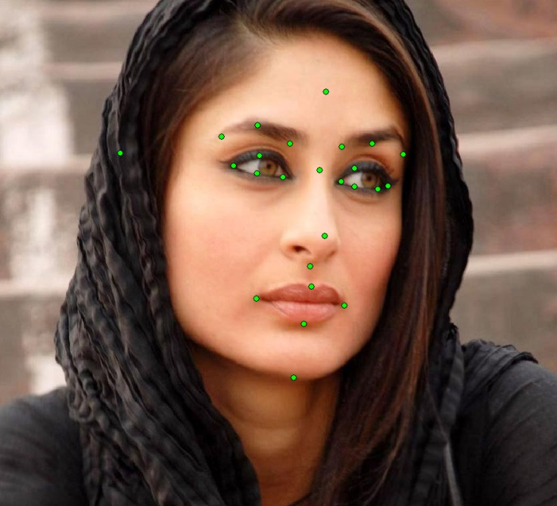

1. Take a head and with the aid of eyes and nose dots establish correct rotation on all three axes (yaw, roll and rotation). Rotate model head to exactly correspond the picture.

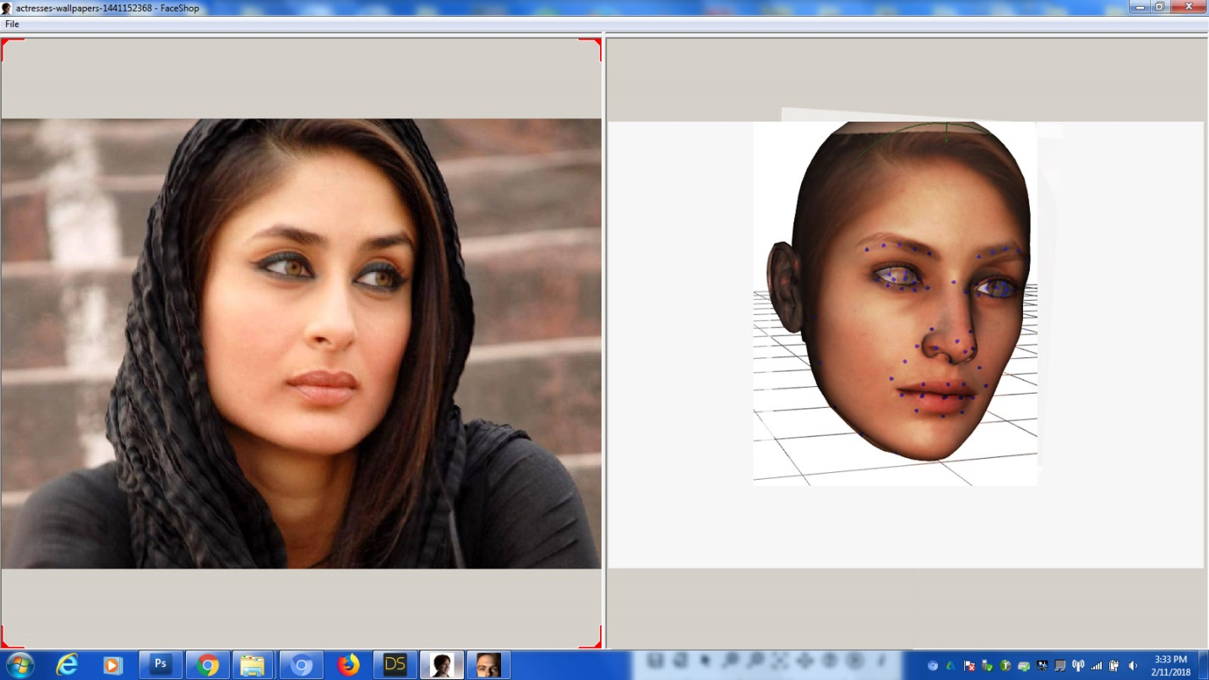

1. Project Luxand dots to the right side to the model ad observe difference between model and dots.

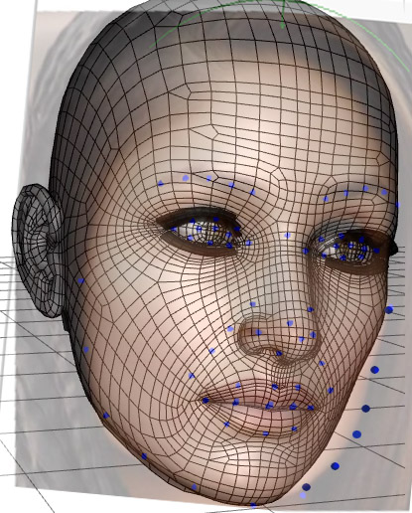

1. The deformation task is to deform the mesh in 3D to correspond to the Luxand dots. Here the jaw shape is clearly different from the blue dots.

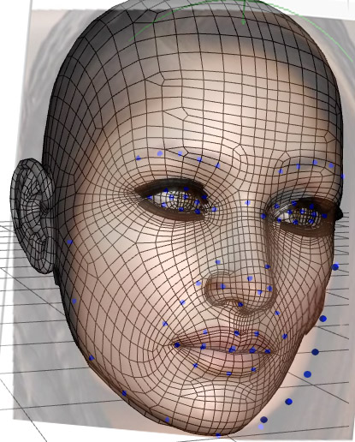

1. The mesh is deformed by finding the nearest nod of the mesh to the corresponding dot.

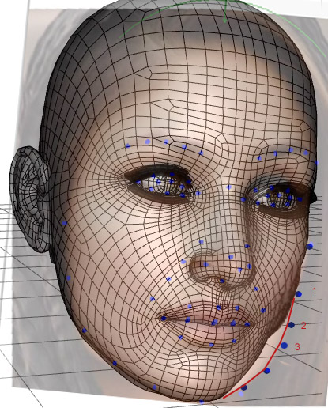

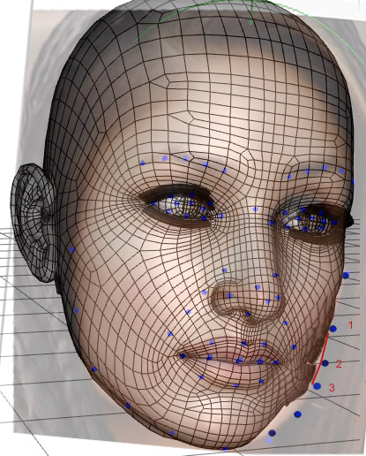

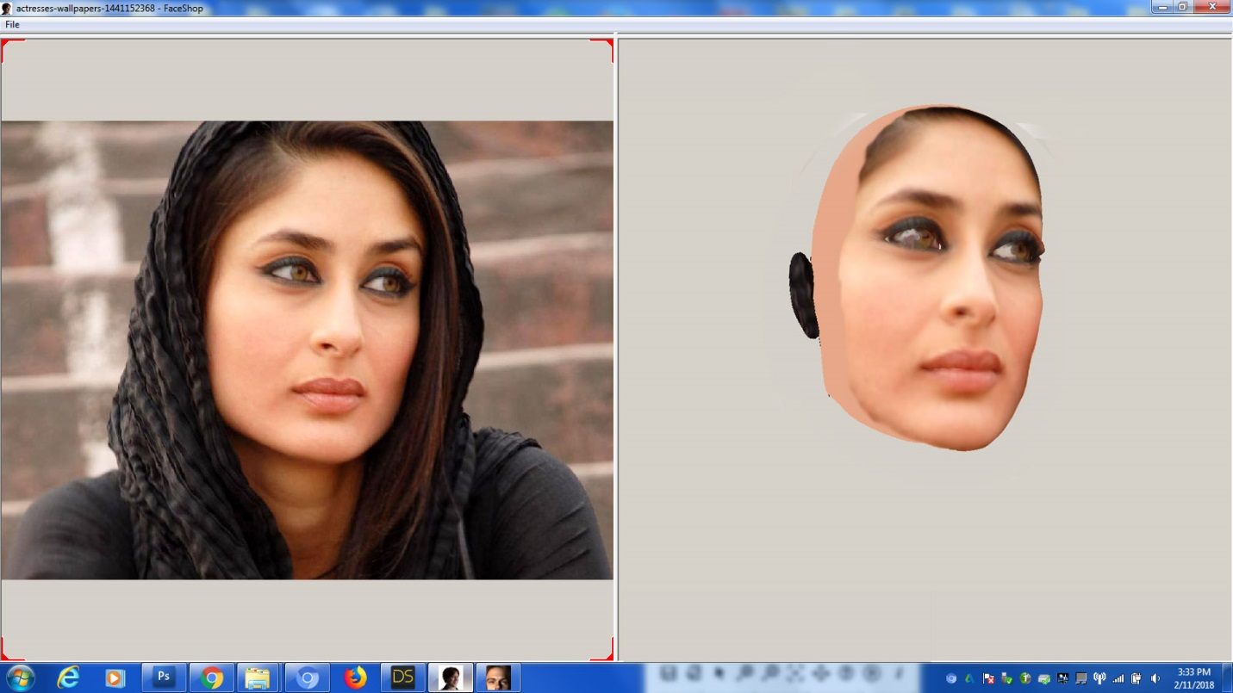

The resulting shape is textured and rotated into frontal. Mirror from good side to bad side.